- In your own words, give brief explanations of the following statements.
- The shapes of mercury and water menisci are different.
- The boiling point of water is lower at higher elevations.
- Ice floats on top of liquid water.
- A water strider is able to “walk” on water.
- Molecules that are more polar (have larger dipole moments) have higher melting points.

- Write a paragraph explaining why the boiling point, the melting point, and the density of water are considered anomalous. How does hydrogen bonding account for the properties of water?

- Rank the following molecules in order of increasing boiling point:
H₂S, H₂O, SiH₄, CH₄, PH₃

- For each of the following compounds, give:
- The molecular formula
- A condensed structural formula
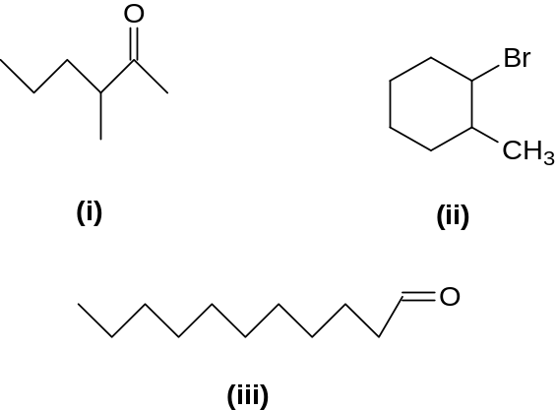

- For each of the compounds for which the skeleton formulas are given below:
- Draw a Lewis structure (electron-dot formula), assuming each atom has a complete octet of valence electrons.
- Show the formal charge on any atom where it is not zero.
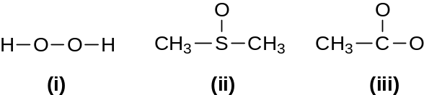

- Indicate whether the following pairs of structural and/or condensed formulas represent:
- Different compounds
- The same compound
- Constitutional isomers
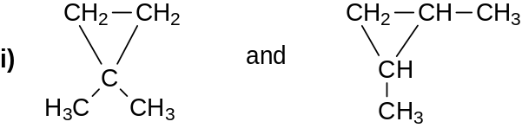
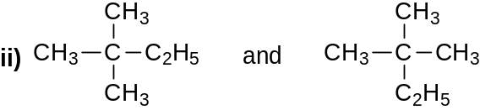
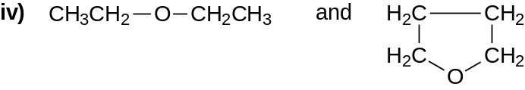

- Using the VSEPR method, predict the shapes of the following molecules. Draw the structure of each and indicate with an arrow the direction of its net dipole moment, if any.
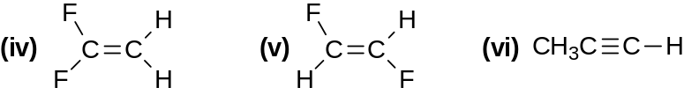

- Which member of each of the following pairs of compounds would you expect to have the higher boiling point? Briefly explain your answer.
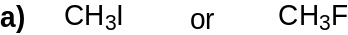
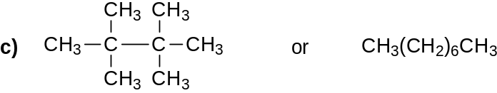
- Which of the following pairs are resonance structures of the same compound?
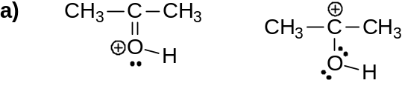
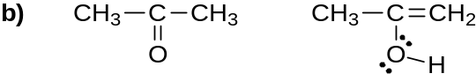
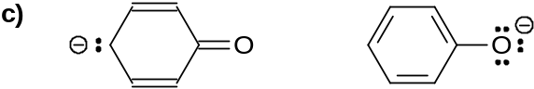
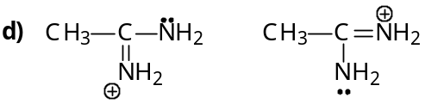

- Identify all the functional groups in each of the following molecules:
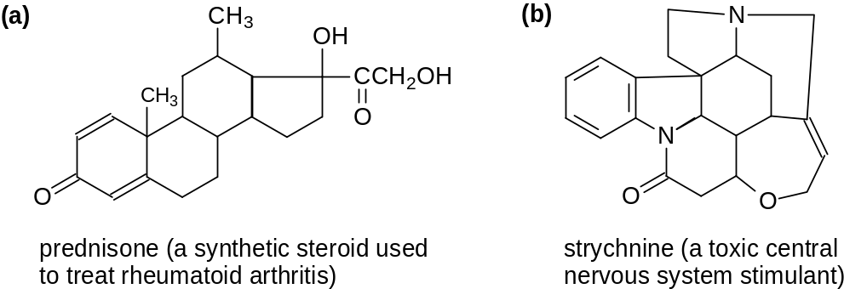
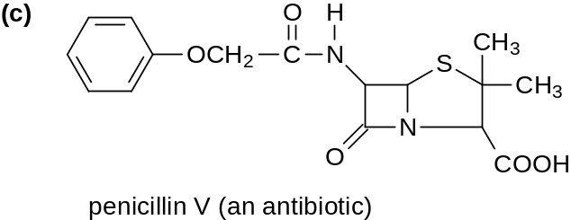

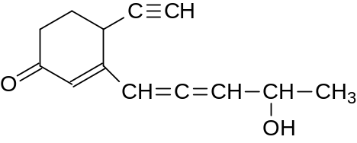
For the above compound:
- Give the orbital hybridization (sp³, sp², sp) for each atom except hydrogen.
- Show the composition (sigma and pi) of all the multiple bonds.
- State whether it is a 1°, 2°, or 3° alcohol.

- a. Complete the following acid-base equations and indicate each conjugate acid-base pair:
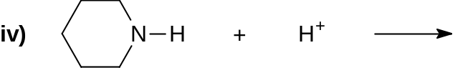
b. Boric acid, H₃BO₃, is a weak acid. Using electron-dot formulas, its reaction in water can be shown as:
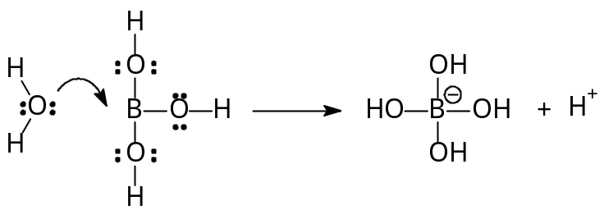
Is boric acid a Brønsted acid or a Lewis acid?

- There are five constitutional alkene isomers of C₅H₁₀. Draw the dash structural formula for each and indicate any that also exhibit cis-trans isomerism.

